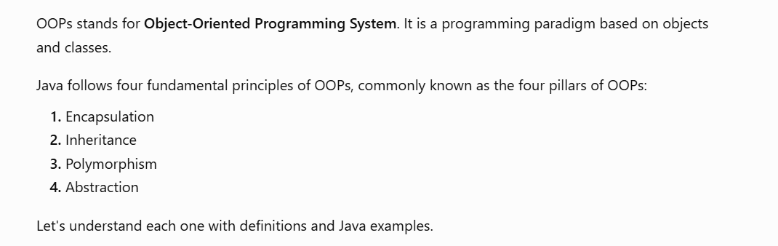
1)
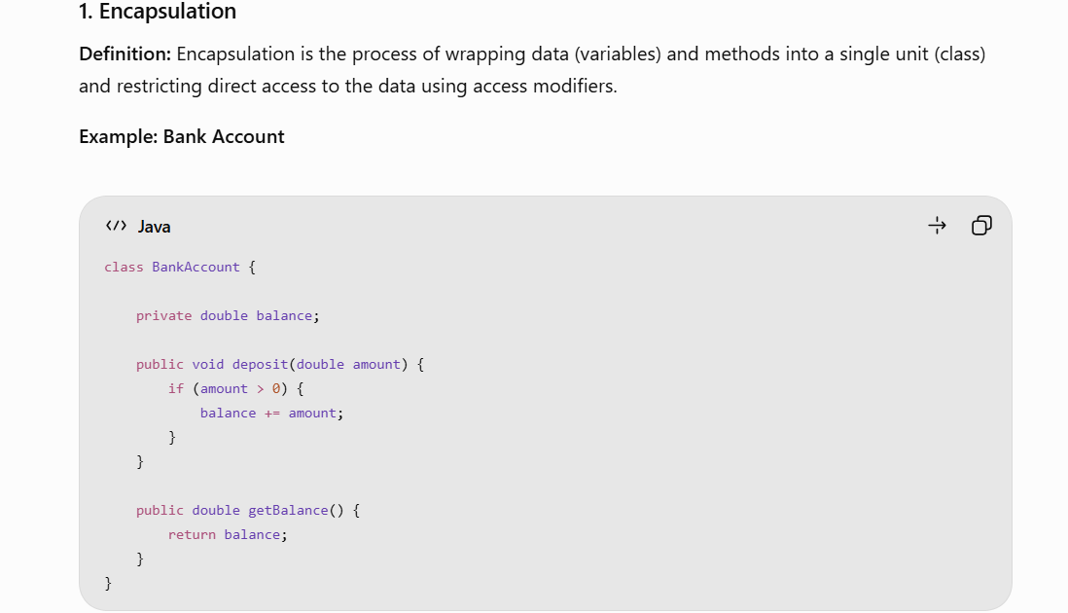
Explanation:
- balance is declared as private.
- It cannot be accessed directly outside the class.
- We use public methods to access and modify the balance.
Key point: Encapsulation is achieved using access modifiers and controlled access through methods.
2) 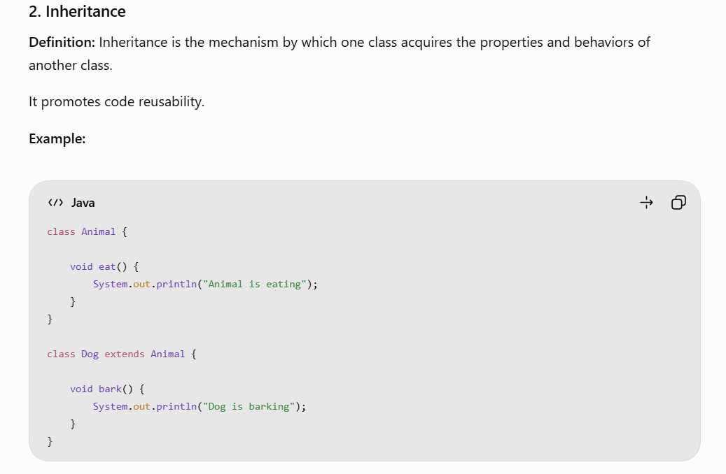
Explanation:
- Animal is the parent class.
- Dog is the child class.
- Dog inherits the eat() method from Animal using the extends keyword.
Key point: Inheritance represents an IS-A relationship.
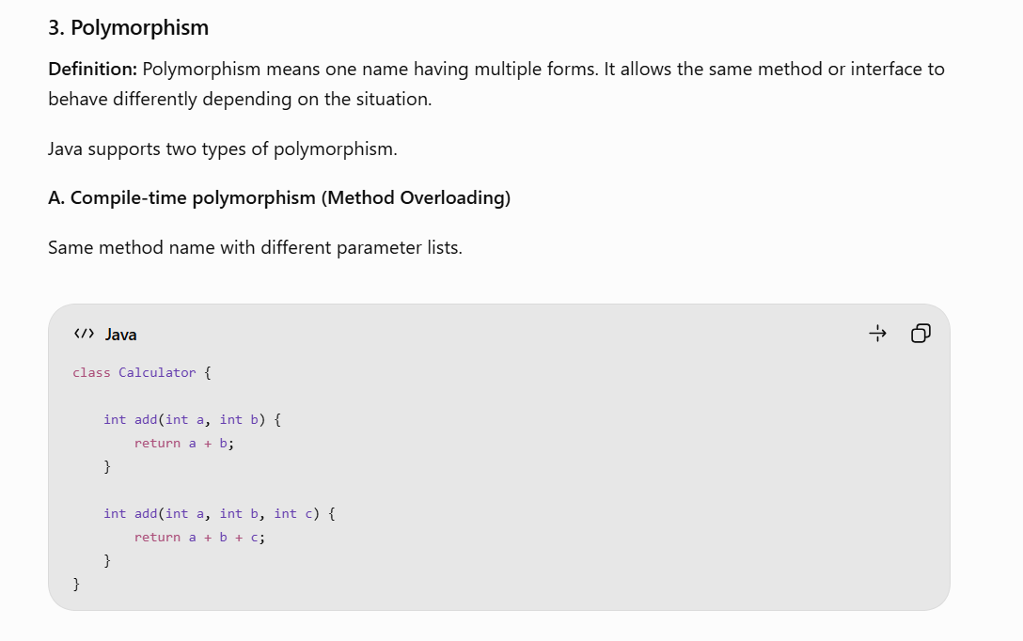
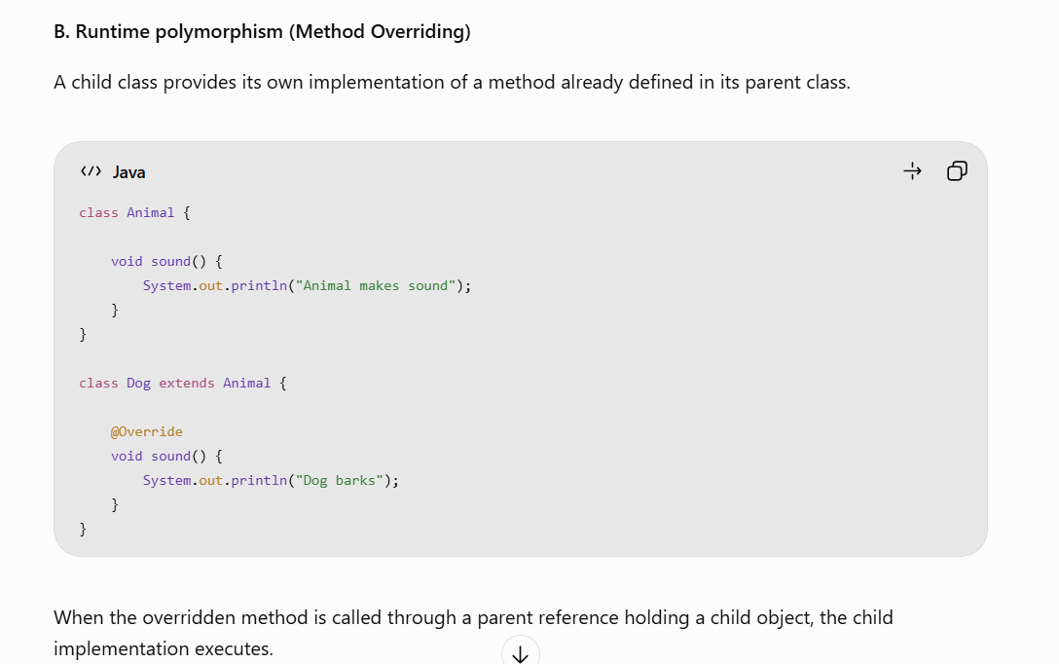
Key point: Method overloading is compile-time polymorphism, while method overriding enables runtime polymorphism.
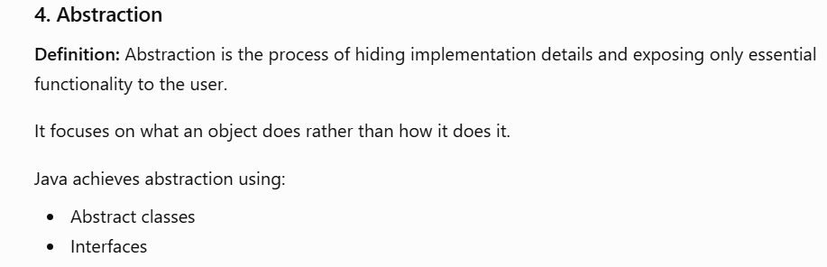
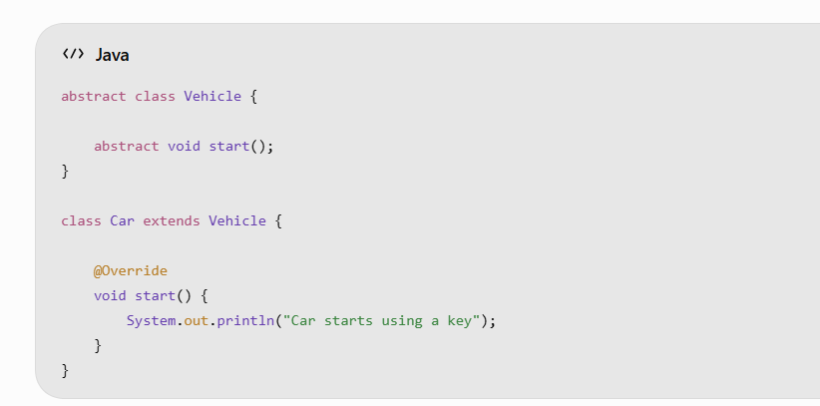
Here, the Vehicle class defines what operation should be performed, while the Car class provides the implementation.
Key point: Abstraction hides implementation complexity.


Some Important Points on Principles of OOPs
1. The four pillars of OOPs are Encapsulation, Inheritance, Polymorphism and Abstraction.
2. Encapsulation protects the internal state of an object by restricting direct access to its data members.
3. Encapsulation is commonly implemented using private variables and public getter and setter methods.
4. Inheritance establishes an IS-A relationship between parent and child classes and promotes code reusability.
5. Java supports single, multilevel and hierarchical inheritance through classes, but does not support multiple inheritance through classes.
6. Java supports multiple inheritance of type through interfaces.
7. Polymorphism allows a common method or reference to represent different behaviors depending on the object or method parameters.
8. Method overloading is resolved at compile time, whereas overridden instance methods are resolved at runtime.
9. Dynamic Method Dispatch is the mechanism through which Java determines which overridden instance method to execute at runtime.
10. Abstraction reduces implementation complexity by exposing essential operations while hiding unnecessary implementation details.
11. Java achieves abstraction using abstract classes and interfaces.
12. An abstract class can contain both abstract and concrete methods, constructors, instance variables and static members.
13. Interfaces support multiple inheritance of type and help achieve loose coupling between components.
14. Abstraction and encapsulation are different: abstraction hides implementation complexity, whereas encapsulation protects and controls access to internal state.
15. Inheritance and composition are both code-reuse mechanisms. Composition represents a HAS-A relationship and can provide more flexible object design.
16. Constructors are not inherited or overridden, but they can be overloaded.
17. Private methods cannot be overridden because they are not accessible to subclasses.
18. Static methods are hidden rather than overridden; they do not participate in runtime polymorphism.
19. The super keyword is used to access superclass members and invoke superclass constructors.
20. The this keyword refers to the current object and can be used to access its members or invoke another constructor in the same class.
21. OOP principles improve modularity, maintainability, extensibility, reusability and testability.
22. Applying OOP principles appropriately helps achieve loose coupling and high cohesion in software design.
23. A class is not necessarily initialized when you access one of its static fields.
24. A static context cannot directly access non-static members because non-static members belong to an object, not to the class itself.

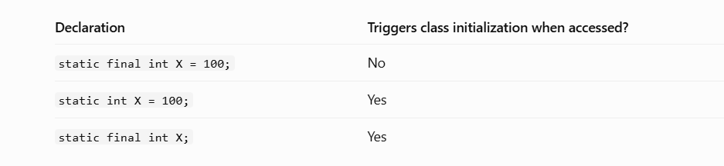
25. A static final variable is not automatically a compile-time constant. It must also be initialized with a compile-time constant expression
26. In Java, either this() or super() can be the first statement of a constructor, but not both. Placing this() after super() in methods violates Java compilation rules.
27. Class.forName() triggers class initialization (executing static blocks), whereas loadClass() only loads and optionally links the class without executing its static initializer blocks.
28. String is also a final class in Java. A String object cannot be an instance of an unrelated class.
29. The instanceof() operator checks whether an object is compatible with a particular type. Java performs type-compatibility checks at compile time before evaluating the condition at runtime.
The instanceof operator always returns false when the reference being checked is null.

null instanceof AnyClass -------- Returns false but not an NullPointerException.

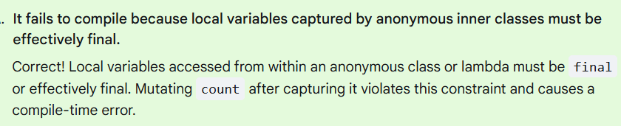

Map because Map does not implement the Collection interface.


